IdeaStamp: A Decentralized Idea & Preprint Priority Registry
Timestamped Commitments for Research Provenance and Dispute-Resistant Attribution

EECE571G Blockchain Software Engineering
Assignment 2 - Web3 dApp Whitepaper
Group Members: 78229960 Kaiwen Liu 93906261 Qi Xu 18861757 Chun Pang Wong
Date: Mar 6, 2026

Table of Contents
- Executive Summary
- 1. Introduction & Background
- 2. Product-Market Fit
- 3. Tokenomics & ERC20 Token Model
- 4. Project Roadmap & Timeline
- 5. Revenue Model & Business Strategy
- 6. Conclusion & Future Prospects

Executive Summary
IdeaStamp is a Web3 native provenance and priority registry for research ideas, notes, and preprints. It solves a common collaboration pain point in research: when two or more people discuss an idea early, disputes can later arise about who proposed it first. Traditional evidence (chat logs, emails, notebooks) is fragmented, easy to cherry-pick, and hard to verify by third parties.
IdeaStamp introduces a commit–timestamp–reveal workflow that allows an author to (i) create an immutable, verifiable timestamped commitment to an idea without publicly revealing it, and (ii) later reveal the original content to prove prior possession. Commitments are stored on-chain for finality and ordering; optional encrypted content is stored off-chain on content addressed storage. A dispute module enables community-verified resolution when two parties claim priority over similar ideas.
The protocol is designed for day-to-day usability: a lightweight web interface, an API for integration with Overleaf/GitHub/Notion workflows, and optional organization accounts for labs. The IDEA token (ERC20) aligns incentives across authors, reviewers/arbitrators, and infrastructure contributors, funding long-term operation through protocol fees and memberships.

Key properties
- Private proof-of-priority via salted commitments (no premature disclosure).
- Public verifiability via on-chain timestamps and deterministic reveal verification.
- Dispute resolution via staking, review, and on-chain finalization.
- Composable identity and attribution (wallet-based, optional ORCID-style linking).
- Sustainable operations via protocol fees, memberships, and a governed treasury.

1. Introduction & Background
Research is a collaborative, iterative process. Early-stage ideas are often exchanged informally: in hallway conversations, lab meetings, chat messages, or shared notes. When an idea later becomes valuable e.g., a publishable direction, a grant proposal, or a commercial opportunity, participants may disagree about who originated the core insight. These disputes are painful, damage trust, and can discourage open discussion.
Existing evidence mechanisms are inadequate. Email threads and chat logs are easy to manipulate via selective screenshots. Traditional notebooks are private and hard to verify by outsiders. Preprint servers provide timestamps only at the point of public disclosure, which is too late for many priority disputes and forces premature publication.
IdeaStamp addresses this gap by providing a verifiable, privacy preserving proof-of-priority for research ideas and preprints. Users create an on-chain commitment to a document hash (with a secret salt), producing a tamper evident timestamp. Later, the user may reveal the document and salt to prove that they possessed the content at or before the commitment time. The protocol supports optional encrypted storage, controlled disclosure, and dispute resolution for contested claims.

What problem does our Web3 dApp solve?
We aim to make it cheap and routine for researchers to establish: “I had this exact idea (or preprint draft) by time T,” without requiring them to publish it immediately.
The system must satisfy three constraints simultaneously: (i) verifiability by third parties, (ii) privacy before the author chooses to disclose, and (iii) usability within normal research workflows.

What is the motivation behind our project?
The goal of IdeaStamp is to reduce the social and institutional friction caused by unclear research attribution. Researchers should be able to share ideas freely without worrying that early discussions will weaken their claim to priority. By providing a lightweight mechanism to cryptographically prove prior possession of an idea, IdeaStamp encourages open collaboration while preserving fair attribution. The protocol allows researchers to document their ideas privately and reveal them only when necessary, balancing transparency, privacy, and usability.

Why a Blockchain?
Priority is fundamentally about ordering and finality. A blockchain provides an append only, globally consistent timeline that is hard to rewrite and easy to audit.
IdeaStamp stores only compact commitments on-chain (hashes and minimal metadata). Full documents remain off-chain, avoiding cost and preserving confidentiality.

Existing Solutions and Differentiation
Several existing platforms and technologies partially address aspects of research provenance and digital timestamping, but none fully solve the problem of private, verifiable idea priority in collaborative research environments.
Traditional preprint servers such as arXiv or open publishing platforms like ScienceOpen allow researchers to publicly share manuscripts and receive a timestamp upon publication. However, these systems require immediate public disclosure of the work, which may discourage early sharing of ideas and preliminary research directions. Authorea also supports collaborative writing and publishing workflows, but it primarily focuses on document collaboration rather than verifiable proof of idea ownership. ￼
Within the emerging Decentralized Science (DeSci) ecosystem, platforms such as ResearchHub aim to improve scientific communication and funding by rewarding researchers for publishing and reviewing work. These platforms focus on open collaboration and incentive alignment but do not specifically address private proof-of-priority for early-stage ideas. ￼
Other blockchain-based tools focus on document timestamping rather than research workflows. For example, OpenTimestamps provides cryptographic proof that a piece of data existed at a particular time by anchoring document hashes into the Bitcoin blockchain. This allows users to verify the existence of a document independently without relying on a trusted third party. ￼ However, such tools are generic and do not provide research-specific workflows, dispute resolution mechanisms, or incentive systems.
Academic research has also proposed blockchain-based publishing systems such as PubChain, which aim to decentralize scientific publishing and incentivize authors, readers, and reviewers through token-based rewards. These systems primarily focus on replacing the traditional journal infrastructure rather than solving the problem of early-stage idea attribution. ￼
IdeaStamp differentiates itself by combining several features that are typically addressed separately by these systems. First, it introduces a commit reveal workflow with salted commitments, enabling users to prove prior possession of an idea without publicly disclosing it. Second, the protocol includes a research-focused dispute resolution mechanism where challengers and arbitrators can stake tokens to resolve contested priority claims. Finally, the platform is designed as a research-native workflow tool, integrating easily with common academic environments such as collaborative writing platforms, coding repositories, and lab documentation systems.
Together, these features position IdeaStamp not as a replacement for publishing platforms, but as a complementary provenance layer for research ideas, enabling verifiable attribution before formal publication occurs.

2. Product-Market Fit
IdeaStamp targets researchers who frequently collaborate, iterate on drafts, and share partial ideas before publication. The most immediate users are graduate students, postdocs, and principal investigators in fast-moving fields where priority disputes are common and time-to-publication is long.
The protocol is intentionally minimal at the core (a priority registry), but enables product layers that increase adoption: lab workspaces, integrations with existing writing/code tools, and discoverability controls (private, shared-with-team, or public).

Who are the target users?
Individual researchers: want an inexpensive, quick way to establish priority on an idea, a method variation, or an experimental result.
Research groups/labs: want team-level provenance for internal ideas, with controlled sharing and role-based access.
Open science communities: want transparent attribution and credit for contributions such as reviews, replications, and commentary.

What market gap does our solution fill and what is our value proposition?
Priority evidence today is either too weak (informal logs) or too strong/late (public disclosure). IdeaStamp provides a middle ground: strong evidence without disclosure.
The value is both defensive (reducing conflict risk) and enabling (encouraging freer idea exchange because attribution is provable).

How do we plan to achieve adoption?
Start with a narrow, high-frequency workflow: “stamp this note/draft now.” This can be implemented as a browser extension and an API.
Offer immediate personal value without requiring token holding: allow paying protocol fees via sponsored relayers or stablecoin, while gradually introducing token-based features (staking, governance).
Partner with labs and student organizations for pilots; provide organization dashboards and exportable proof reports (verifiable on-chain).
Create social proof via public badges for revealed ideas/preprints and verifiable reviewer contributions, improving CV signaling.

User Journey (Commit–Reveal)
Commit: User writes an idea note (e.g., Markdown/PDF). Client computes content hash and creates a salted commitment. Transaction stores commitment and timestamp.
Optional storage: User may upload an encrypted blob to content-addressed storage, referencing its CID in metadata.
Reveal (optional): When needed (e.g., dispute, publication), user reveals the document + salt. Anyone can verify that it matches the earlier commitment.
Dispute (optional): If two claims conflict, challengers stake tokens and submit evidence; arbitrators review and the protocol finalizes an outcome.

3. Tokenomics & ERC20 Token Model
IdeaStamp uses an ERC20 utility token, IDEA, to align incentives and fund long-term protocol maintenance. The token is not required for basic stamping in the early phases (to minimize friction), but becomes important for dispute resolution, curation, governance, and sustainable reward distribution.
Tokenomics are designed around two principles: (i) protect the integrity of priority claims (through staking and penalties), and (ii) reward valuable ecosystem work such as arbitration, integration development, and community growth.

Define the ERC20 token structure
Token name: IDEA; symbol: IDEA; decimals: 18; fixed max supply: 1,000,000,000 IDEA.
The protocol treasury (DAO-controlled) can spend tokens allocated to it for grants, audits, liquidity, and ecosystem incentives, under on-chain governance.

Token Utility in the Ecosystem
Staking for disputes: initiating a dispute requires a stake. Frivolous disputes can be penalized (slashing) to prevent spam.
Arbitrator/reviewer incentives: qualified reviewers/arbitrators stake IDEA to participate and earn rewards for accurate, timely decisions.
Governance: IDEA holders vote on protocol parameters (fees, staking amounts, reviewer selection, treasury spending).
Curation and reputation: optional modules can use IDEA-weighted signals to highlight high-quality revealed ideas/preprints and to fund bounties.
Infrastructure incentives: integration maintainers (plugins, SDKs) may receive grants from the treasury.

Commitment Privacy and Front-Running Resistance
To prevent front-running (someone copying an idea and committing first), the on-chain transaction only stores a salted commitment hash, not the plain content hash.
We recommend a commit format that includes the author's address and chain ID, so commitments cannot be replayed across chains and cannot be claimed by other accounts: commitment = H(chain_id || author_address || content_hash || salt || metadata_hash).

Token Allocation
The following allocation is designed for a research-first protocol with long-term sustainability and strong community ownership. Vesting and lockups reduce short-term sell pressure and align contributors with multi-year outcomes.
Figure 1 shows the proposed IDEA token allocation across ecosystem categories.
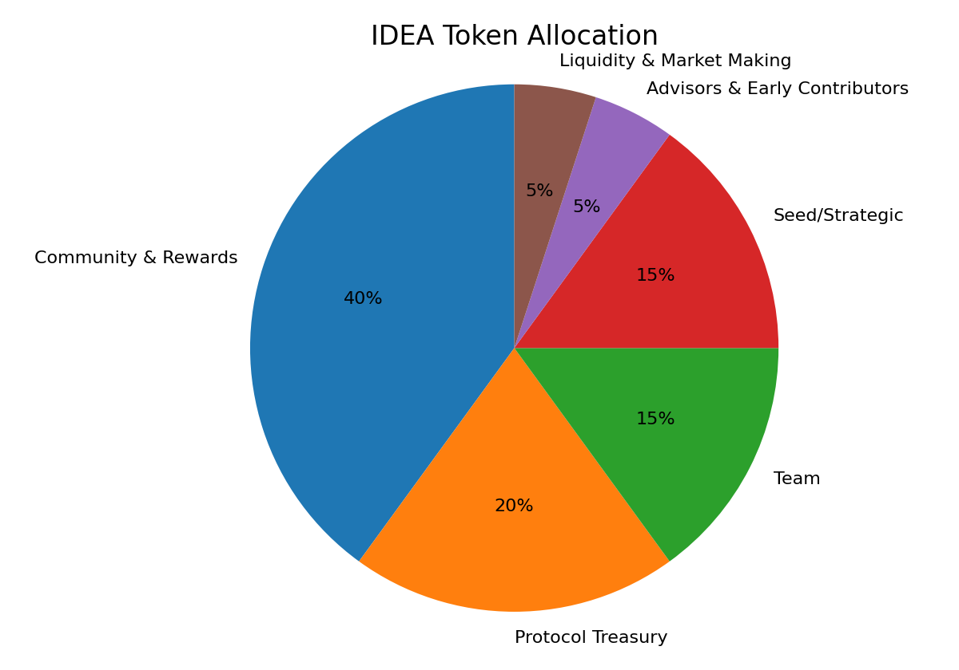
Figure 1. IDEA token allocation (proposed).

Proposed allocation & vesting schedule
Bucket | Share | Purpose | Vesting / Lockup
Community & Rewards | 40% | Staking rewards, arbitration incentives, user grants | Unlocked linearly over 48 months
Protocol Treasury (DAO) | 20% | Audits, ecosystem grants, ops runway, insurance fund | Unlocked linearly over 60 months
Team | 15% | Core builders and long-term maintainers | 12 mo cliff + 36 mo vest
Seed/Strategic | 15% | Early funding / strategic partners | 6 mo cliff + 24 mo vest
Advisors & Early Contributors | 5% | Advisors, early reviewers, pilot labs | 12 mo vest
Liquidity & Market Making | 5% | DEX/CEX liquidity, incentives | Partially unlocked at TGE

Key economic parameters (initial proposal)
Parameter | Initial setting | Rationale
Stamp fee (base) | Low fixed fee per commitment (paid in stablecoin or IDEA) | Discourages spam; funds ops
Reveal fee | Optional; typically free | Encourage later disclosure when needed
Dispute initiation stake | Configurable stake in IDEA | Deters frivolous disputes
Reviewer stake | Small stake to participate | Align reviewer behavior
Slashing | Loss of stake for proven bad behavior | Enforce integrity

4. Project Roadmap & Timeline
For the course submission, we intentionally scope the roadmap to what a 3‑person team can build in ~4 weeks. The deliverable is a working stamping MVP on a public testnet (smart contract + minimal web client + verification). Token launch, DAO governance, and formal dispute arbitration are treated as design-only extensions (optional future work), not required for the course build.

Key milestones for development, testing, and deployment:
Week 1: Spec + prototype. Finalize the commitment and metadata schema, define the threat model (timestamp/ownership claims), and build a local prototype that produces commitments (hashes) with salts and optional file hashes.
Week 2: Smart contract MVP. Implement the IdeaRegistry (commit + optional reveal) with events, access control, and unit tests. Deploy to a testnet (e.g., Sepolia / Polygon Amoy) and verify writes/reads via a simple script.
Week 3: End-to-end app. Add a minimal web UI (wallet connect, stamp, reveal, verify) and an indexer/verifier service (can be lightweight: listen to contract events and display stamped records).
Week 4: Hardening + demo + report. Add input validation, basic anti-spam (fee or rate-limit), clearer UX, and a demo workflow. Prepare evaluation (latency/cost) and documentation for submission.
Optional (post-course): Extend toward encrypted storage, organization workspaces, richer reputation, and (if desired) a token-backed staking/arbitration module after security review.

Timeline for community engagement and adoption:
Class pilot: recruit classmates (or a small lab group) to stamp ideas during weekly meetings and collect UX feedback on commit/reveal and verification.
Open-source workflow: publish the contract + frontend + verifier with clear README, and accept small PRs (e.g., better UI, improved indexing).
Lightweight incentives (course scope): use non-transferable badges (e.g., simple NFTs) or off-chain points to credit early testers and reviewers; keep ERC20 tokenomics as a design proposal only.

Roadmap summary (weeks)
Week | Milestone | Deliverables
1 | Spec + prototype | Commitment scheme, metadata, threat model; local hash/stamp prototype
2 | Testnet contract MVP | IdeaRegistry contract, unit tests, deployment, CLI/script verification
3 | End-to-end app | Web UI (wallet connect, stamp/reveal/verify), event indexer/verifier
4 | Hardening + demo | Basic anti-spam (fee/rate-limit), UX polish, docs, demo walkthrough
Optional | Post-course extensions | Encrypted storage, org workspaces, reputation, staking/arbitration (design/optional)

5. Revenue Model & Business Strategy
IdeaStamp aims to be sustainable without relying solely on token appreciation. The protocol uses a mixed model of (i) low protocol fees for stamping and dispute operations, (ii) membership subscriptions for organization features, and (iii) treasury-governed grants and partnerships.
Revenue choices are constrained by adoption: researchers are price-sensitive and may avoid complex payment flows. Therefore, we keep the base stamping fee small and allow payment in stablecoin or through sponsored relayers in early phases.

What are the sources of revenue?
Protocol fees: a small fee per stamp (commit transaction) and a fee component for disputes. Fees are paid in stablecoin or IDEA and can be partially burned to align incentives. For example, stamping fees may initially range from $0.01–$0.10 per commitment depending on network costs, making it inexpensive enough for frequent use while still discouraging spam.
Organization memberships: paid plans for labs/universities offering team management, private workspaces, higher storage limits, and compliance features.
Premium tooling: paid API tiers, batch-stamping for experiments, and exportable audit reports for institutions.
Partnerships and grants: collaboration with open science foundations and educational programs, funded through treasury governance.

Sustainability and cost structure:
Costs include smart contract audits, indexer hosting, encrypted storage gateways, customer support for pilot institutions, and ongoing development. As more researchers use the platform, the registry becomes a growing historical record of research provenance. This network effect increases the credibility and value of the system, making it increasingly difficult for alternative systems to replicate the accumulated record of verified commitments.
A portion of protocol fees flows to a safety reserve (insurance fund) controlled by the DAO to cover incident response and to subsidize users in low-resource settings.

Business strategy with long-term growth plan:
Beachhead: graduate labs and student research groups. Provide free or heavily subsidized stamping up to a monthly quota.
Expand to institutions: departments and universities can offer IdeaStamp as an official provenance tool, similar to an internal lab notebook system but with public verifiability when desired.
Long-term: become a shared attribution layer for multiple DeSci applications (review marketplaces, replication bounties, funding coordination).

6. Conclusion & Future Prospects

Summary of the vision and next steps:
IdeaStamp makes research collaboration safer and more open by providing verifiable, privacy-preserving proof-of-priority for ideas and preprints. By combining salted commitments, on-chain timestamps, optional encrypted storage, and a staking-based dispute module, the protocol reduces the human and institutional costs of attribution conflicts.
In the near term, the focus is on shipping a simple, reliable stamping workflow and integrating with existing research tooling. In the long term, the protocol can evolve into an attribution and reputation layer that supports open peer review, replication incentives, and community-led governance of research infrastructure.
Ultimately, IdeaStamp aims to become a foundational provenance layer for scientific collaboration, enabling researchers to share ideas more openly while maintaining verifiable attribution in a decentralized and transparent infrastructure.

Expected impact:
Lower social friction in collaborations by making provenance easy and verifiable.
Enable controlled sharing: users can prove priority without publishing early.
Provide new ways to recognize contributions (reviews, replications) through verifiable on-chain records.

Future prospects:
Integration with academic identity (optional) and citation tooling.
More sophisticated similarity and prior-art workflows (e.g., cryptographic commitments to semantic fingerprints, optional).
Interoperability with other DeSci protocols and funding mechanisms.

